GENERAL PATIENT RECORD
Patient’s name: | Date of birth: Age:
Phone: | Email:

You are scheduled for a series of non-invasive treatments with the Emsculpt. The device is indicated for improvement of abdominal tone, strengthening of the abdominal muscles, development of firmer abdomen. Strengthening, toning and firming of buttocks. Initials: _____
Your treatment provider will discuss your specific treatment needs. Recommended number of treatments is 4. The treatment is typically about 30 minutes per session, with sessions separated by at least two days. Completing a full treatment series is necessary to maximize treatment efficacy. You may need additional treatments depending on your goals. Initials: _____
Before the treatment, you are not required to do anything special, however, keeping your body well hydrated is recommended. On the day of the treatment, you are advised to wear comfortable clothing which allows flexibility for correct positioning during the treatment. You will be asked to remove all metallic accessories and electronic devices. Initials: _____
I acknowledge that a successful treatment outcome can be affected by smoking or excessive alcohol consumption, as well as: eating disorders or on-going medication. While no special diet is required, you are encouraged to eat healthy to help promote and maintain results. Initials: _____
The treatment does not require anesthesia. During the application, you will feel intense muscle contractions in the treated area. The procedure doesn’t require any recovery time. Typically, you can get back to your daily routine right after the treatment. Initials: _____
I acknowledge that the treatment should preferably be applied directly over the skin. If not, I am aware not to wear any metallic accessories (such as jewelry, watch or clothes containing metallic threads) during the treatment. I also acknowledge that I do not have any metallic or electronic implants (such as pacemakers, defibrillators, metallic IUDs, etc.) Initials: _____

Please answer whether you currently have or have had any of the following*:

- Metal or electronic implants YES NO
- Cardiac pacemakers, implanted defibrillators, implanted neurostimulators YES NO
- Drug pumps YES NO
- Pulmonary insufficiency YES NO
- Malignant tumor YES NO
- Fever YES NO
- Metallic IUD YES NO
- Sensitivity or allergy to latex YES NO
- Hemorrhagic conditions YES NO
- Injured or otherwise impaired muscles YES NO
- Heart disorders YES NO
- Epilepsy YES NO
- Recent surgical procedures (muscle contraction may disrupt the healing) YES NO
- Areas of the skin which lack normal sensation YES NO

If you answer YES to any of these questions, please specify:
____________________________________________________________________________________________________________________________________________________________________________________________________________________________________________________________________________________________________________________________________________________________________
Please answer the following:
- Have you been pregnant?
  - C-section
  - Vaginal birth
- Are you satisfied with the strength of your core muscles?
- Are you satisfied with the shape of your buttock?
*For the full range of contraindications, warnings, and cautions, consult your treatment provider.

Treatment considerations

- I am aware that the treatment cannot be applied over the head, heart and neck. Initials: ______
- I am aware that pregnancy and nursing are contraindicated, and pregnant women cannot undergo the treatment. Initials: ______
- I understand that there are certain risks associated with Emsculpt treatments and they include
but are not limited to muscular pain, temporary muscle spasm, temporary joint or tendon pain, local erythema or skin redness and intramuscular fat decrease*. Initials: _____
- I understand that the treatment over injured or otherwise impaired muscles is contraindicated*
Initials: ____
- I understand that the treatment may involve risks of complications or injury from both known and unknown causes, and I freely assume these risks. Initials: ______
- I agree to before and after treatment photographs, measurements and weighing, as this will help for medical evaluation of the results of the treatment. Information will be acquired for medical records or marketing purposes. Initials: ______
- I understand the results may vary from person to person and that an exact result cannot be predicted. Completing a full treatment series is necessary to maximize treatment efficacy. It is very unlikely, but it is possible that you will not feel any recognizable result after the procedure. I acknowledge the results may not meet my expectations. Initials: ______
- I certify that I have read this entire document and that I agree with all provisions. I certify that I have had the opportunity to ask questions and these questions have been answered in full to my satisfaction.
I fully understand the treatment conditions, the procedure, and possible side effects. Initials: ______
- I have read the above information, and I request and give my consent to be treated with the Emsculpt by the physician(s) in this practice and his/her designated staff. Initials: ______
My signature below indicates that the above information is accurate and current.
Patient’s signature: ______________________________________ Date: ___________________________
Witness (in print):________________________Signature: _______________________ Date:___________
Practice Name: ____________________________
*For the full range of possible adverse effects and expected device-related treatment sequelae, consult your treatment provider.
THIS PAGE INTENTIONALLY LEFT BLANK

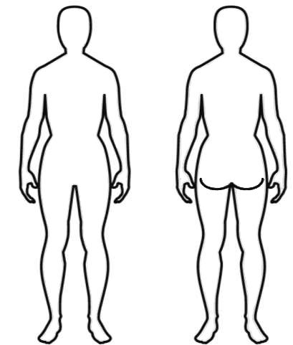
TREATMENT RECORD

Patient’s name or ID: _____________________________________________
Photos taken: YES / NO
Treatment area(s) - describe or mark on diagram:
________________________________________________________________
Weight before 1st Tx/after last Tx: _______/________ Height: ___________

SESSION # | DATE | PROTOCOL | TREATMENT TIME | MAXIMUM INTENSITY  REACHED | CIRCUMFERENCE MEASUREMENT | COMMENTS | OPERATOR  INITIALS
1
2
3
4
5
6
7
8

